Slide1
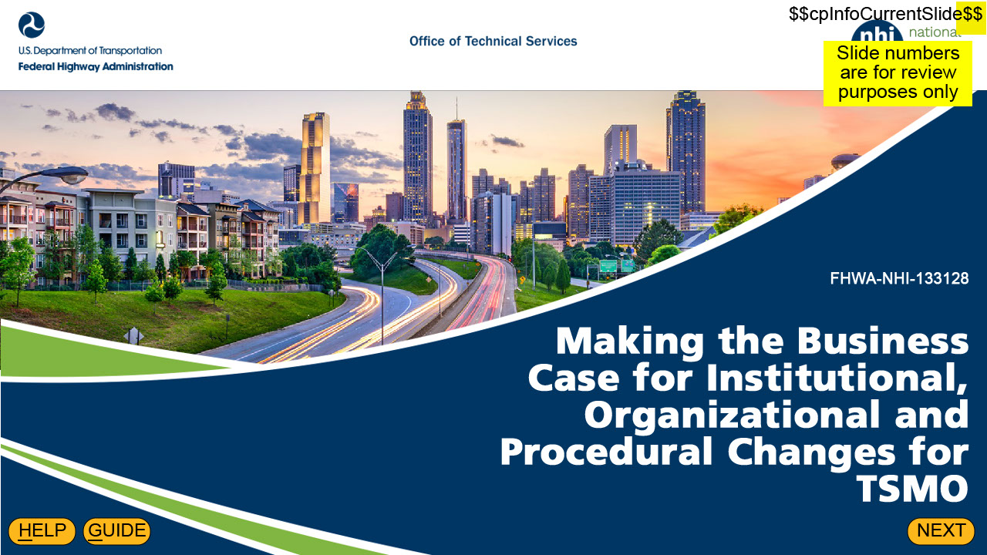
Welcome to Making the Business Case for Institutional, Organizational, and Procedural Changes for Transportation Systems Management and Operations, or TSMO.

Slide2
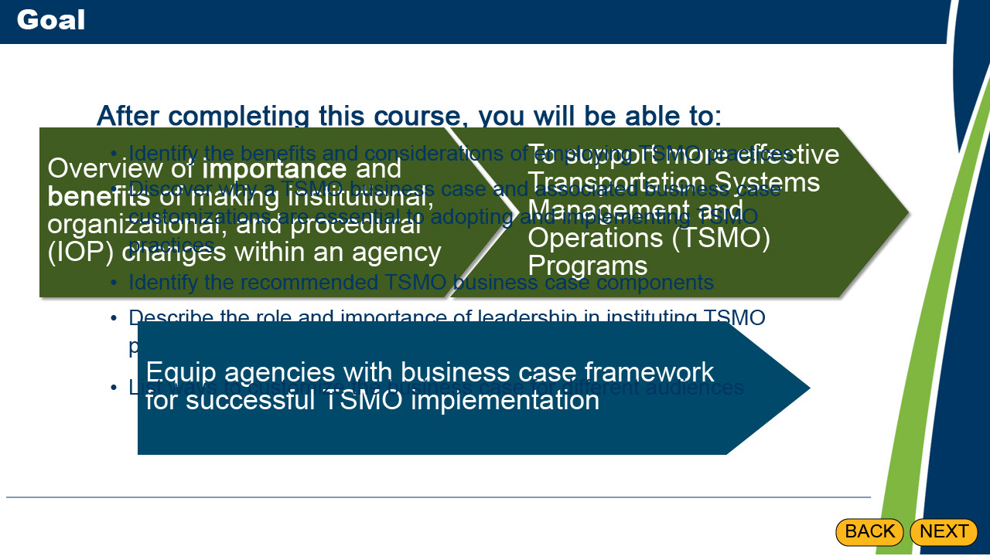
The goal of this course is twofold:
First is to provide an overview of the importance and benefits of making institutional, organizational, and procedural changes within an agency to support more effective Transportation Systems Management and Operations (TSMO) programs.
Second is to equip agencies with a business case framework for successful TSMO implementation throughout their organization.

After completing this course, you will be able to:
Identify the benefits and considerations of employing TSMO practices
Discover why a TSMO business case and associated business case customizations are essential to adopting and implementing TSMO practices
Identify the recommended TSMO business case components
Describe the role and importance of leadership in instituting TSMO practices
List ways to customize the business case for different audiences

Note that throughout this course, a TSMO business case refers more specifically to a business case for IOP changes to improve TSMO, the subject of this course

Text in background
After completing this course, you will be able to:
Identify the benefits and considerations of employing TSMO practices
Discover why a TSMO business case and associated business case customizations are essential to adopting and implementing TSMO practices
Identify the recommended TSMO business case components
Describe the role and importance of leadership in instituting TSMO practices
List ways to customize the business case for different audiences

Slide3
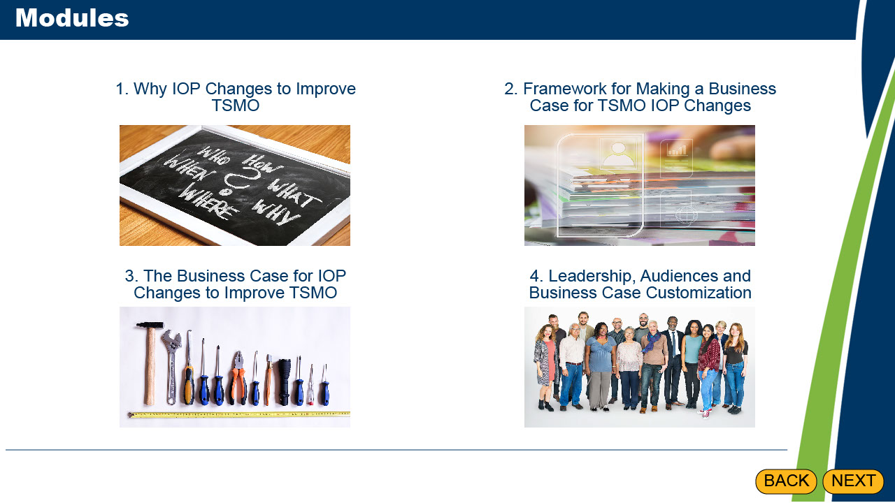
This course is divided into four modules:
Why IOP Changes to Improve TSMO, providing an introduction to what TSMO is and what IOP changes are
Framework for Making a Business Case for TSMO IOP Changes, which introduces you to why business cases for IOP changes to improve TSMO are important and what critical elements to include in them
The Business Case for IOP Changes to Improve TSMO, which gives you tools and resources you can use to build your business case, and
Leadership, Audiences and Business Case Customization, which covers the various audiences for the business case and considerations for tailoring the business case to those audiences.

Slide4
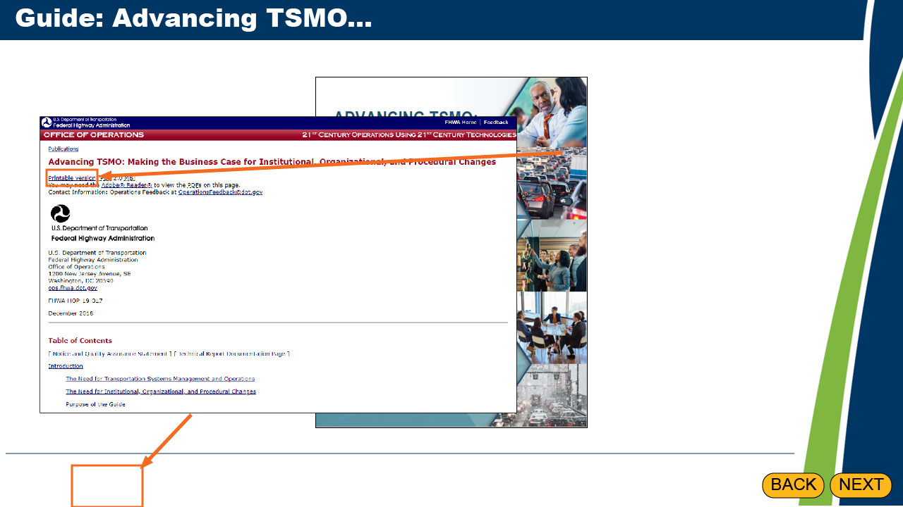
How familiar are you with the guide shown here: "Advancing TSMO: Making the Business Case for Institutional, Organizational, and Procedural Changes“? This guide is the basis for this course, and if you’re not familiar with the guide, you might want to take some time to look through it prior to progressing in this course.

You can access the guide now or at any other time during the course by selecting the Guide button at the bottom of the screen or selecting the letter G. If you want to download a PDF copy of the guide from the website, select the "Printable version" link below the manual title.

Slide5
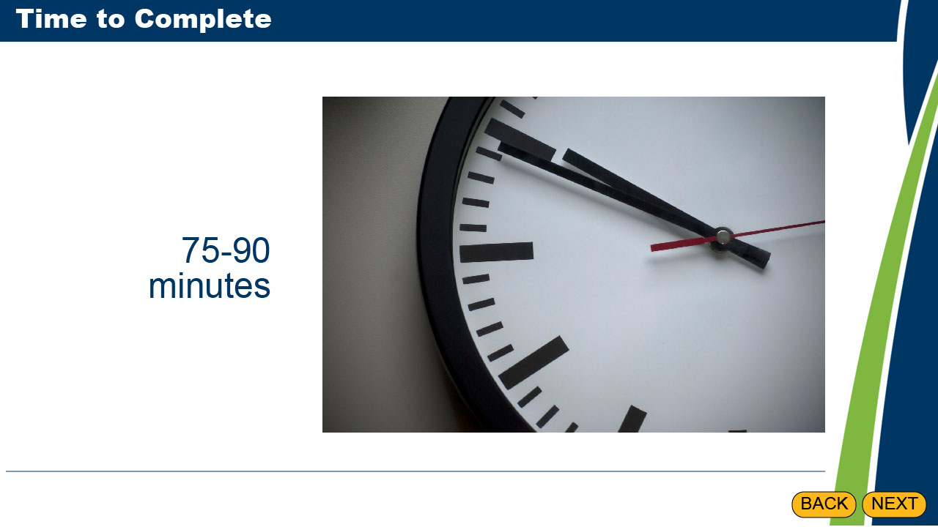
This course should take approximately 75-90 minutes to complete. If needed, you may exit during the module and resume where you left off.

Slide6
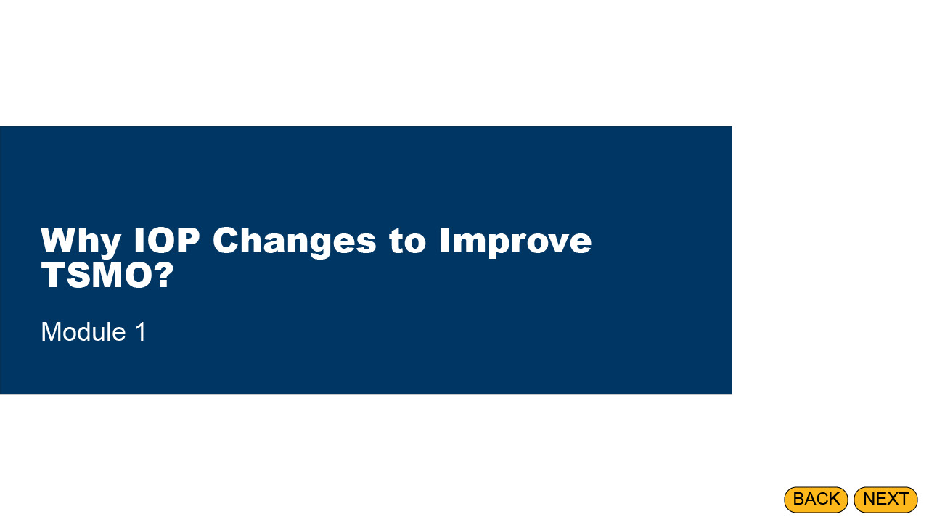
Module 1 introduces foundational information including TSMO benefits and the importance of institutional, organizational, and procedural changes to improve TSMO effectiveness.

Slide7
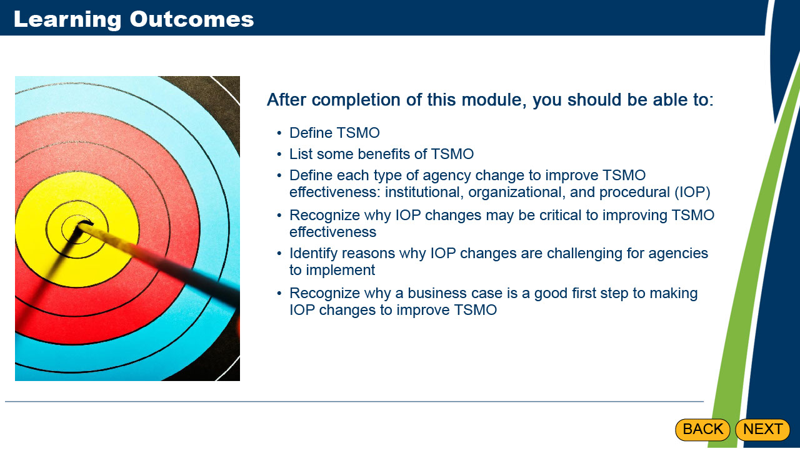
After completion of this module, you should be able to:
Define TSMO
List some benefits of TSMO
Define each type of agency change to improve TSMO effectiveness: institutional, organizational, and procedural (IOP)
Recognize why IOP changes may be critical to improving TSMO effectiveness
Identify reasons why IOP changes are challenging for agencies to implement
Recognize why a business case is a good first step to making IOP changes to improve TSMO

Slide8
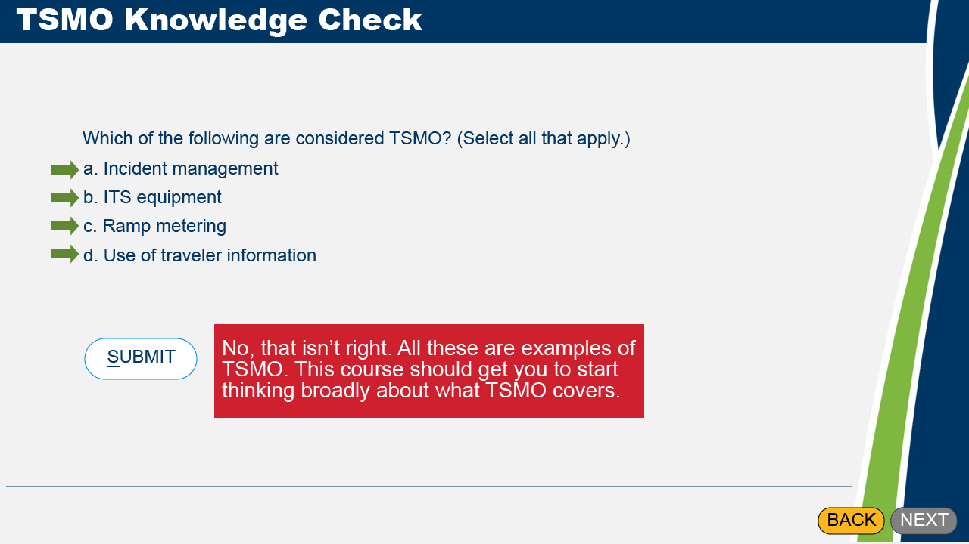
Let’s start with seeing what you know about TSMO. Which of the following are considered TSMO? Select all that apply and then select Submit.

Correct Feedback: Correct. All these are examples of TSMO. You’re already thinking broadly about what TSMO covers.

1st Incorrect Feedback: No, that isn’t right. Try again.

2nd Incorrect Feedback: No, that isn’t right. All these are examples of TSMO. This course should get you to start thinking broadly about what TSMO covers.

Slide9
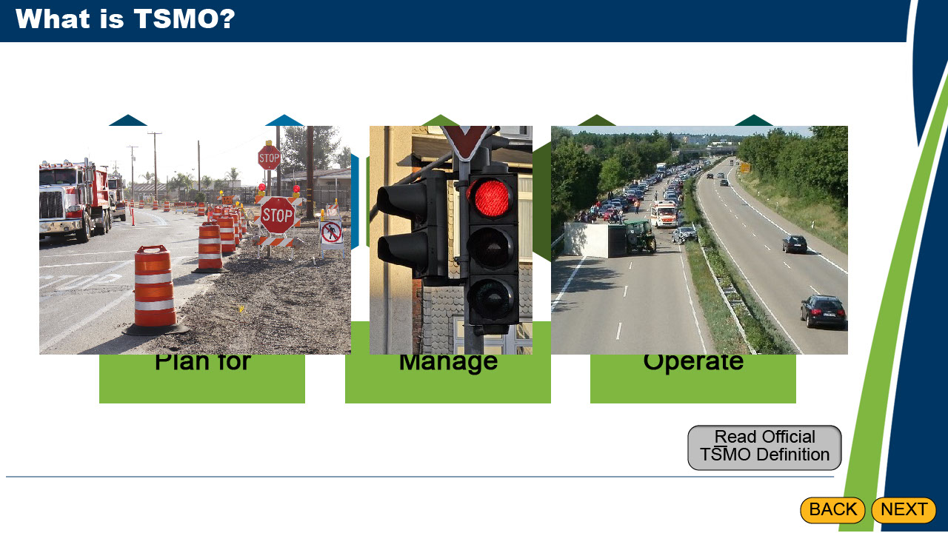
TSMO describes an integrated program of projects, strategies, services, technologies, and processes used to plan for, manage, and operate whole transportation networks to optimize system-wide performance. Many agencies are leveraging TSMO to improve performance in a cost-effective way. TSMO provides a framework for agencies that are dedicated to improving transportation systems for safety, mobility and reliability reasons among others.

Examples may include:
Managing traffic in and around construction work zones to minimize delay and enhance safety of workers and travelers
Upgrading traffic signals for increased traffic responsiveness
Clearing traffic incidents like crashes and breakdowns more quickly to preserve safety of responders and travelers

The benefits of these strategies and more strategies will be discussed on the next page.

Slide10
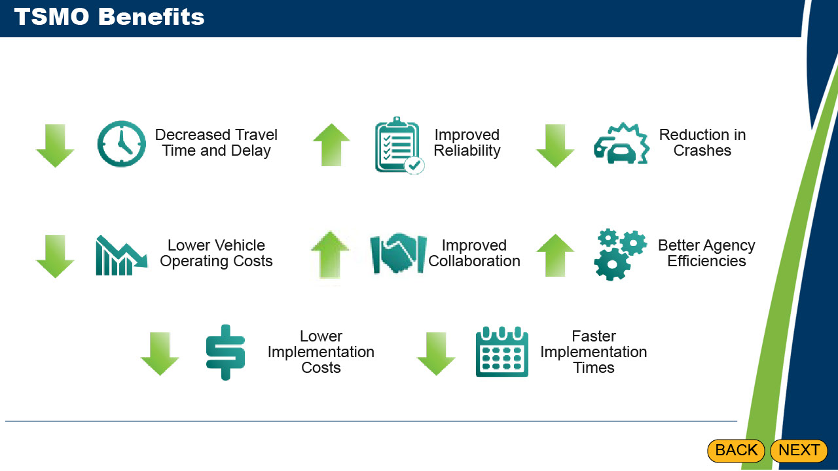
TSMO Strategies, many of which are relatively low in cost and can be accomplished in the short term, result in the variety of benefits shown on the screen. These benefits improve both the experiences of external customers and the processes within the agency.

Slide11
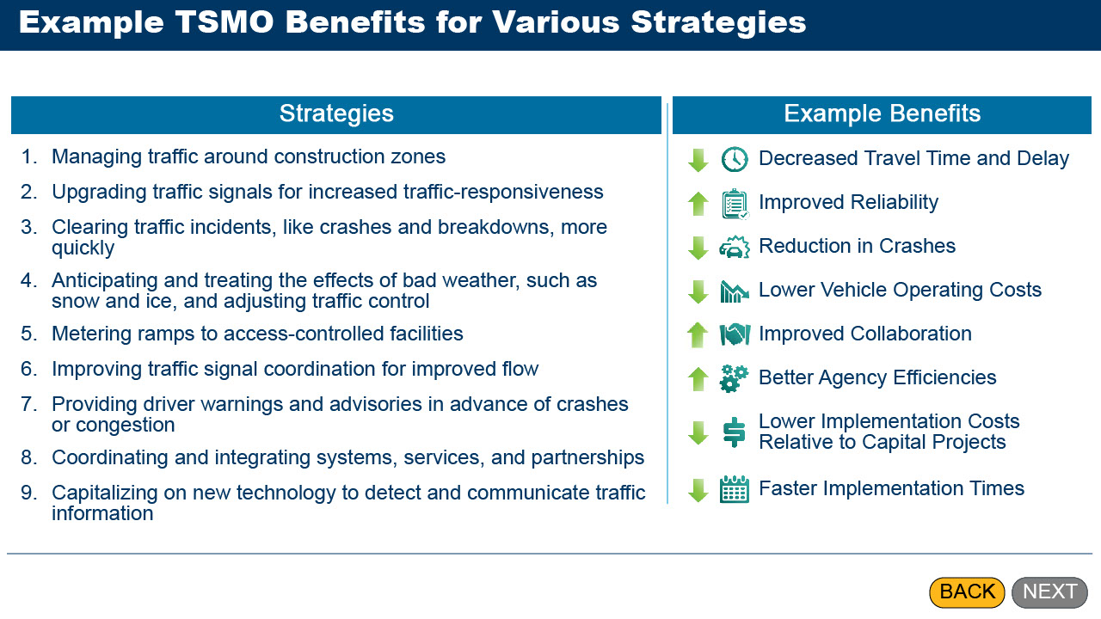
To see some examples of the types of benefits you could expect from various strategies, select each strategy to see its most likely benefits.

Slide12
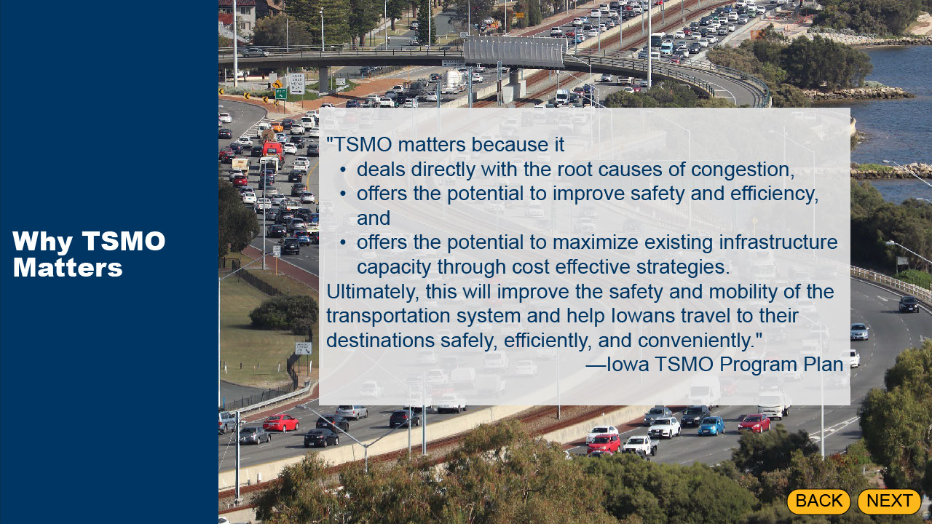
Iowa DOT describes the importance of TSMO in one of its key TSMO documents. The Iowa DOT TSMO program plans says: "TSMO matters because it deals directly with the root causes of congestion, offers the potential to improve safety and efficiency, and offers the potential to maximize existing infrastructure capacity through cost effective strategies. Ultimately, this will improve the safety and mobility of the transportation system and help Iowans travel to their destinations safely, efficiently, and conveniently".
—Iowa TSMO Program Plan

Slide13
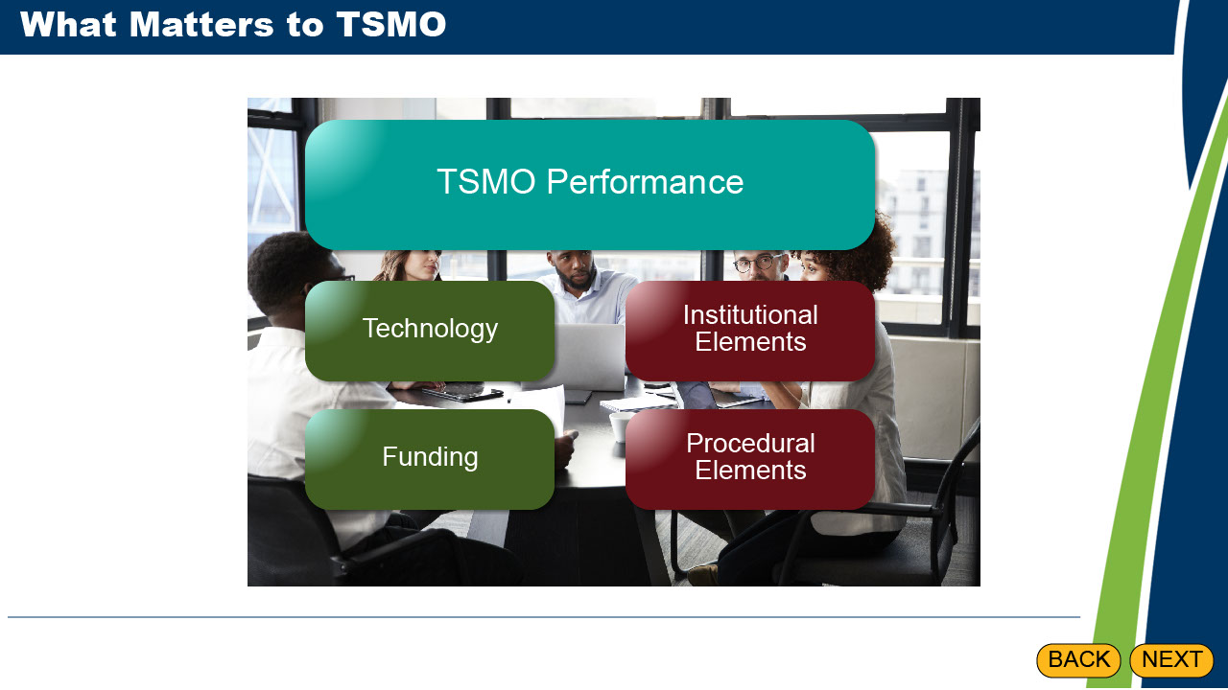
Now that you have seen some examples of what TSMO is and what the benefits are – fundamentally, “why TSMO matters” – let’s review “what matters to TSMO.” It is important to understand how agencies can be effective at implementing TSMO and how they can improve upon their existing capabilities.

While technology and funding are necessary for TSMO, research looking at how agencies could perform TSMO more effectively identified the most successful TSMO programs recognize the importance of institutional and procedural elements as well.

Slide14
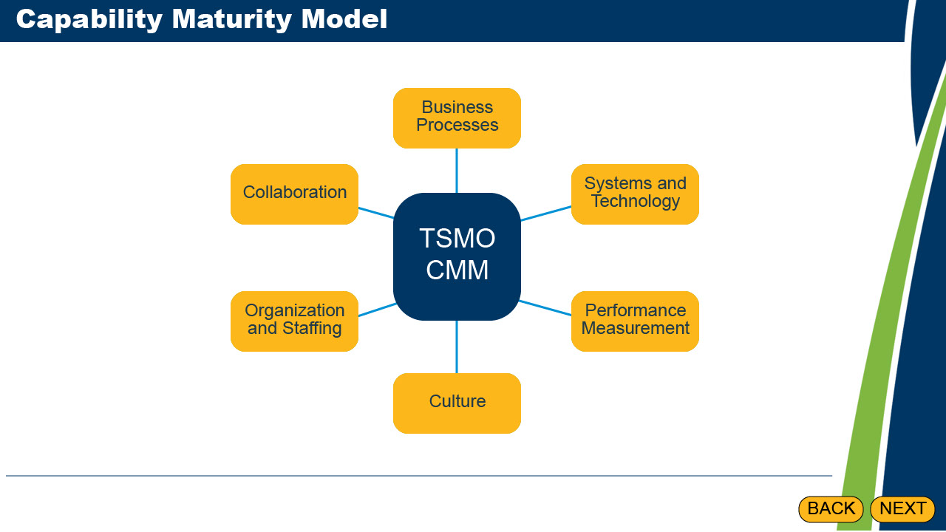
Out of that research a framework emerged called the TSMO Capability Maturity Model, or CMM, that identified the “key dimensions” and levels of agency capability associated with those effective TSMO programs. The capabilities identified were business processes, systems and technology, performance measurement, culture, organization and staffing, and collaboration. This framework was used to create an agency self-assessment process where TSMO management and staff could identify strengths and weaknesses in their program and areas for improvement.

Slide15
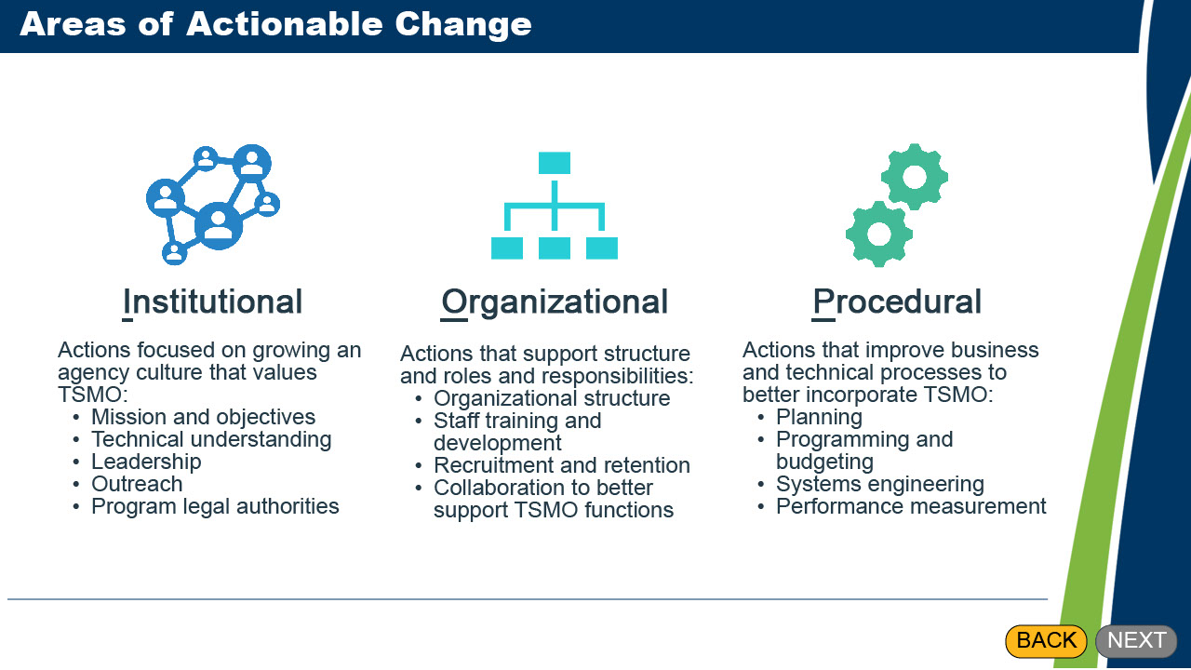
From the TSMO CMM and subsequent associated workshops, came three major areas in need of actionable change: Institutional, Organizational, and Procedural, largely referred to as IOP changes. Select each of the three blocks to learn more about these areas. When you have finished exploring, select next to continue.

Slide16
Institutional actions are focused on growing an agency culture that values TSMO including mission and objectives that include TSMO, technical understanding of TSMO concepts and outcomes, leadership that champions TSMO, outreach to staff, and program legal authorities that support TSMO strategies

Slide17
Organizational actions support a structure and roles and responsibilities to enable effective delivery of TSMO,
including organizational structure,
staff training and development,
recruitment and retention,
and collaboration to better support TSMO functions.

Slide18
Procedural actions improve business and technical processes to better incorporate TSMO, including adjustments in planning, programming and budgeting, systems engineering, and performance measurement.

Slide19
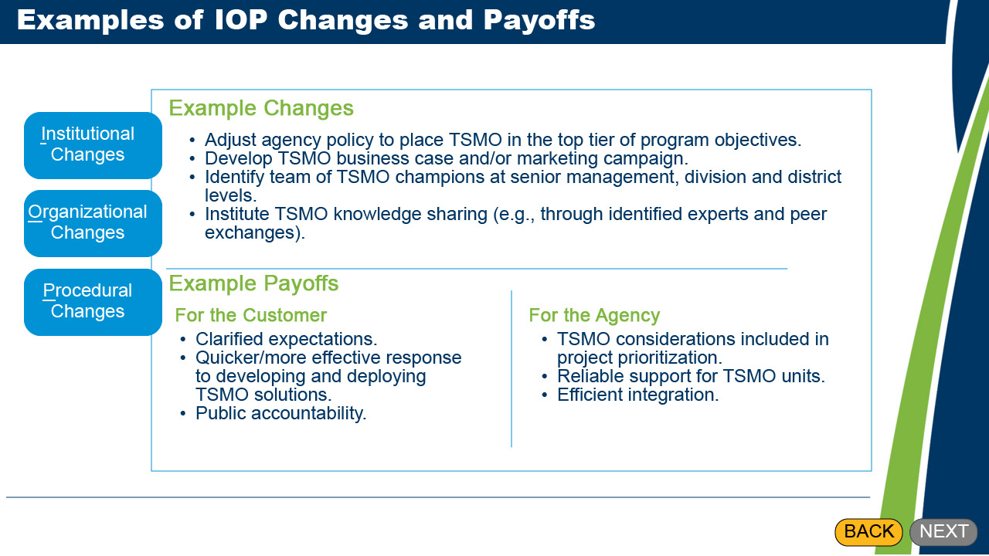
Let's take a look at some examples of IOP changes and their payoffs for both customers and agencies. Select each button, Institutional Changes, Organizational Changes, and Procedural Changes, to learn about some of these cases.

Hidden text
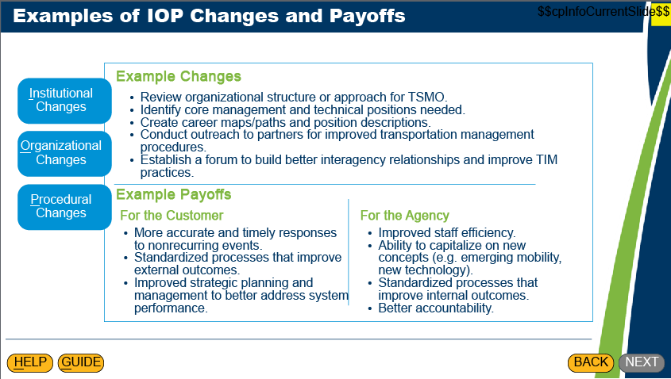

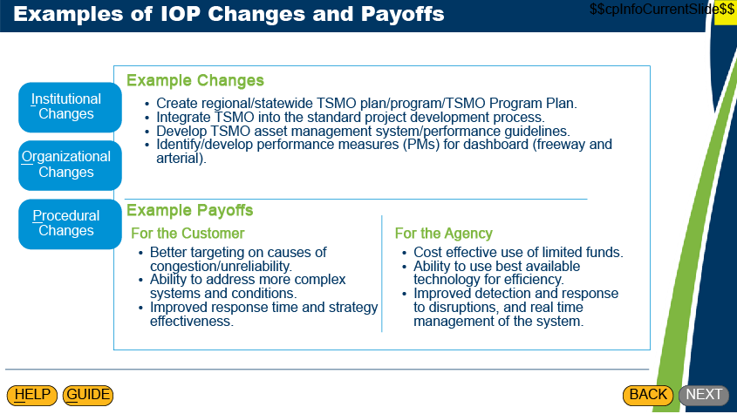

Slide20
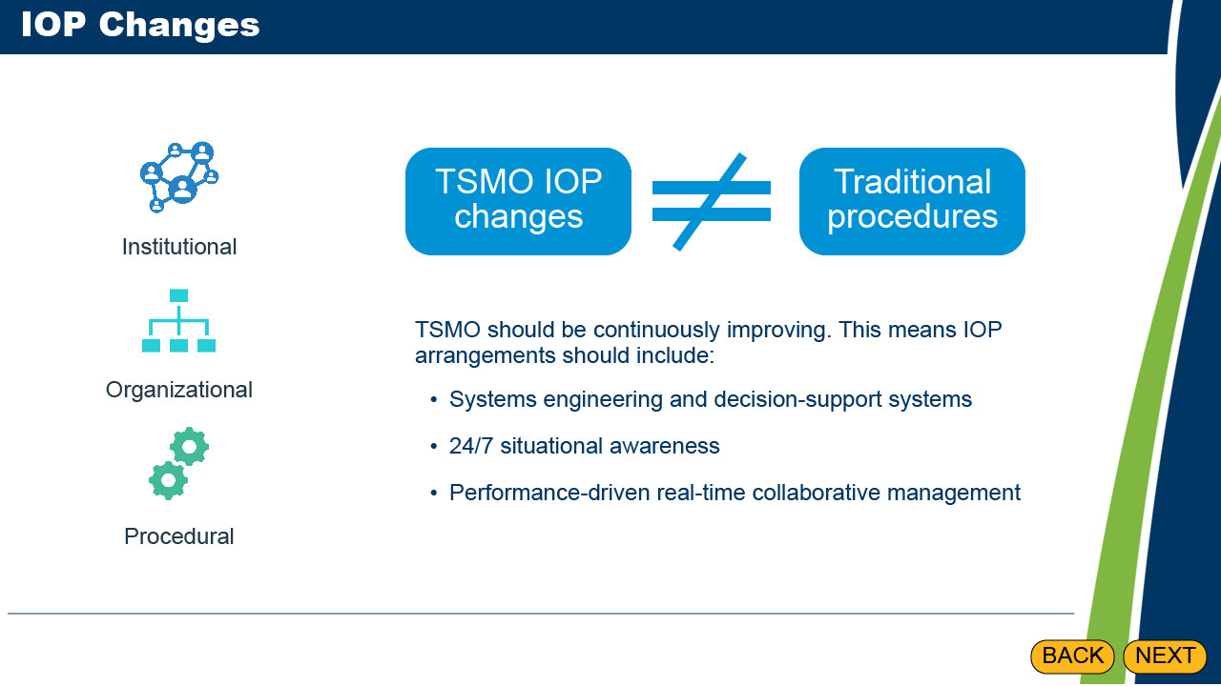
Experience and research have shown that effective TSMO implementation requires developing a set of specific arrangements within State DOTs that differ somewhat from those that have been used to support traditional highway construction and maintenance. These kinds of changes are essential to unlocking the full potential of TSMO strategies toward “mainstreaming” TSMO as an effective, formal first-line agency program.

Continuous improvement in TSMO requires IOP arrangements that are suitable for the distinct characteristics of TSMO strategies, including their systems engineering and decision-support systems, 24/7 situational awareness, and performance-driven real-time collaborative management. Often legacy technical and business processes associated with highway capital project development are not well suited to the characteristics of such TSMO strategies.

And while IOP changes may not be expensive, they can be challenging to implement, as you will see next.

Slide21
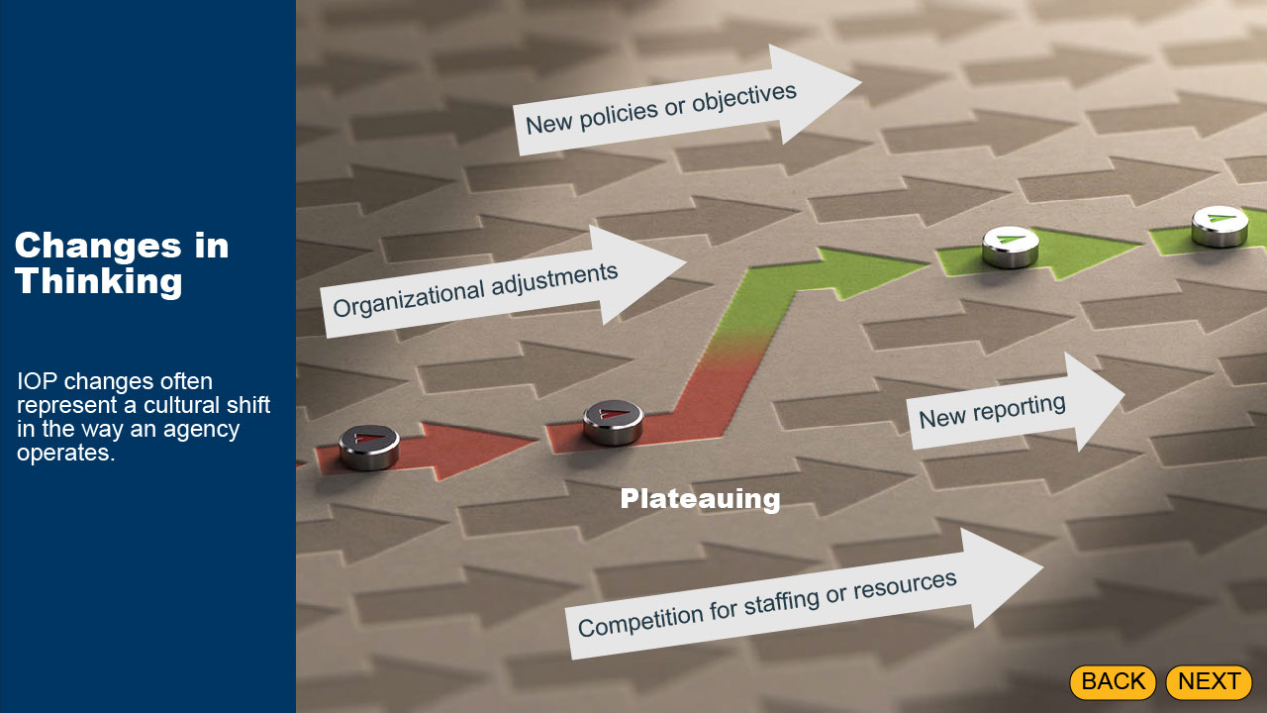
IOP changes often represent a cultural shift in the way an agency operates. They can help improve a TSMO program from being champion-dependent to becoming mainstreamed, and able to endure the departure of a key champion or leader. However, IOP changes may involve taking a look at the agency's mission and objectives and making adjustments to how the agency performs TSMO on a day-to-day basis. To varying degrees, IOP changes may realign some duties within organizational units, introduce new reporting requirements, involve competition for resources or staffing, or require changes that impact the agency more broadly, such as new policies or objectives.

In some instances, a certain level of TSMO strategy effectiveness can be reached but may become stalled because few or no IOP changes have taken place or have not been fully carried out, even though they are known to be worthwhile. This phenomenon is known as “plateauing.”

Slide22
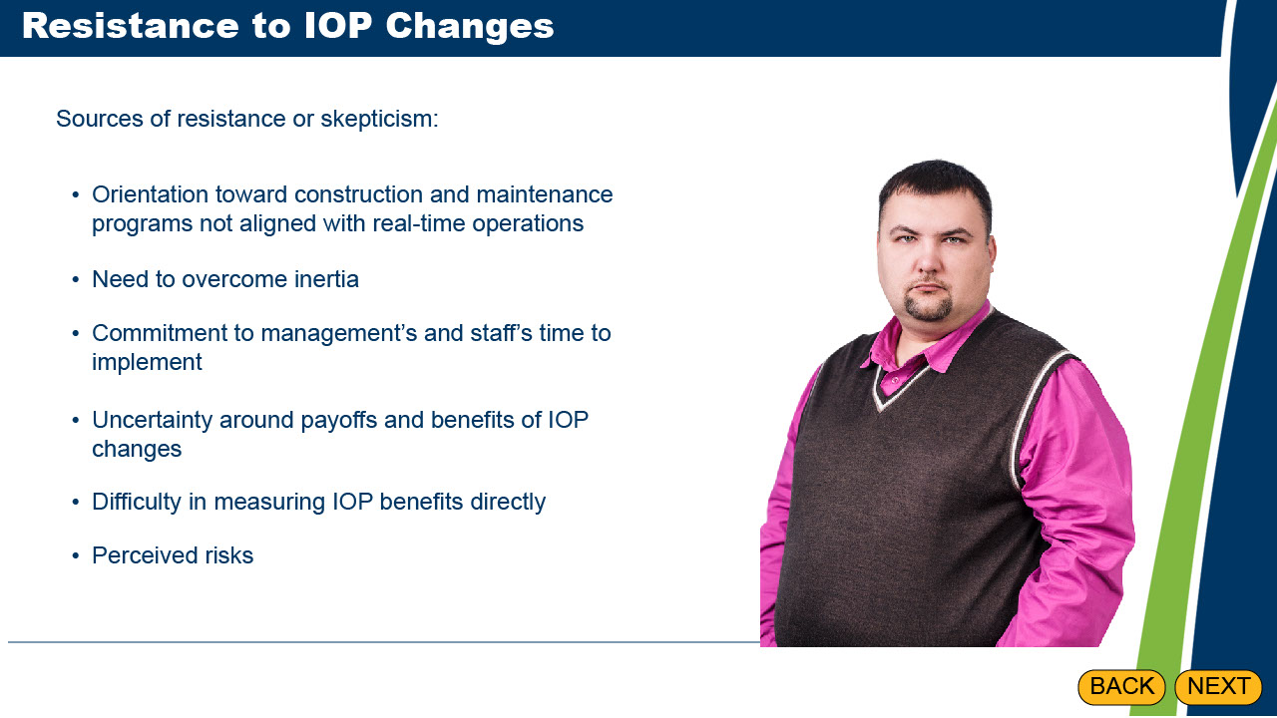
IOP changes may also be challenging to implement because of resistance or skepticism from key agency stakeholders or decision-makers.

Legacy transportation agency IOP arrangements are often oriented toward construction and maintenance programs that are not well aligned with real-time operations or supportive of the continuous improvement needed for effective TSMO. Making changes to these traditional IOP arrangements requires overcoming natural inertia and committing to investments measured mostly in time spent by management and staff.

Skepticism may arise from uncertainty surrounding the payoffs and benefits of making the IOP changes. There is often a lack of clear documentation that indicates what these benefits will be. Quantitative or outcome-based performance metrics are difficult to apply to measure the benefits from IOP changes directly. Perceived risks and institutional resistance, as just described, alongside an inability to implement the changes without leadership action can be too much of a sticking point to overcome.

How do you overcome this resistance? The next slide will show you a way.

Slide23
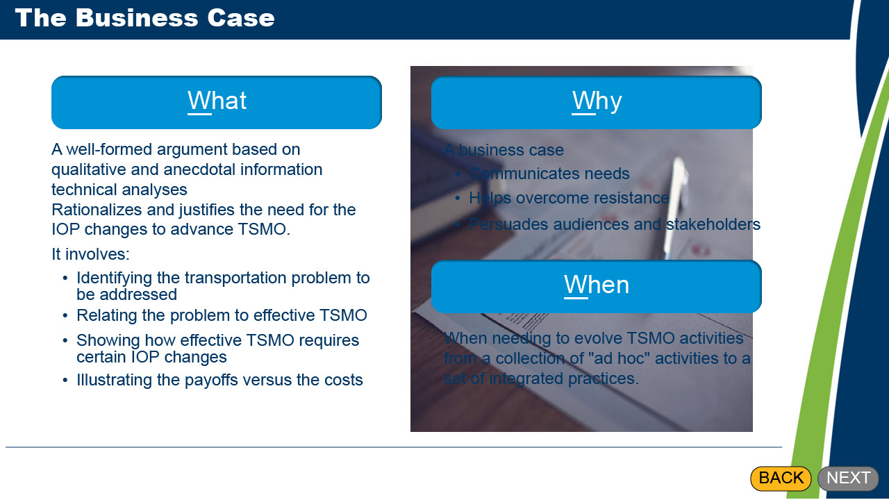
As we have just learned, IOP changes can be challenging to implement. A tool you can use to help ensure a successful implementation is a business case.

Select the What button to learn about what a business case is.
The business case is a well-formed argument based on compelling qualitative and anecdotal information as well as technical analyses that rationalize and justify the need for the IOP changes to advance TSMO. It involves identifying the transportation problem to be addressed; relating the problem to effective TSMO; showing how effective TSMO requires certain IOP changes; and, illustrating the payoffs versus the costs.

Select the Why button to learn about what a business case can help you with.
By building a strong business case you can:
• communicate the need for IOP changes to multiple stakeholders
• overcome resistance, and
• persuade decision makers and key audiences/stakeholders that the changes are necessary.

Select the When button to learn about the best time to create a business case.
In most cases the need for making the business case will occur when an agency already conducts a range of TSMO activities and realizes the need to evolve its TSMO activities from a collection of "ad hoc" activities to a set of integrated practices.

Closing
The online guide and this course cover what should be in a business case according to best practice. Note though that no topics are mandatory; you need to choose what to include based on your particular situation.

Slide24
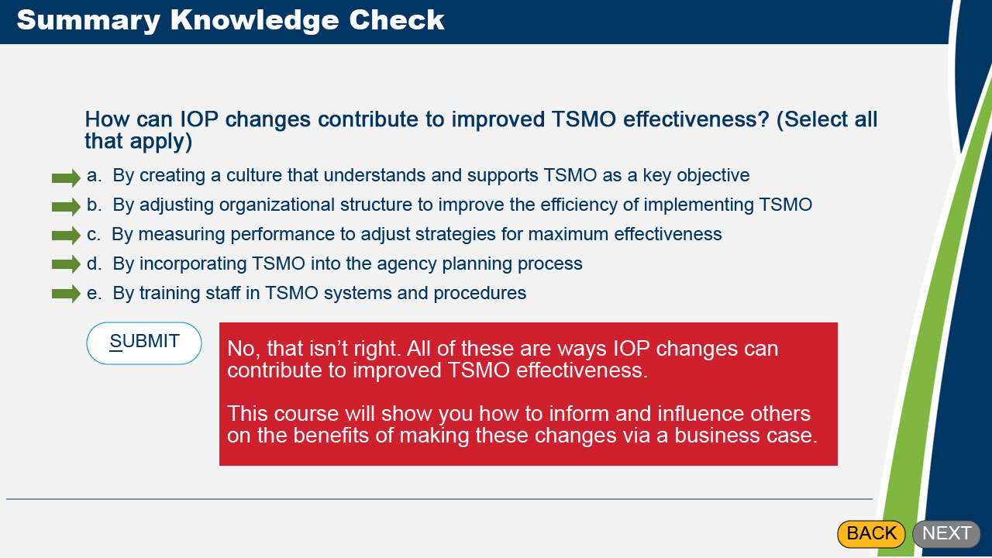
Let’s check what you have learned in this module. How can IOP changes contribute to improving TSMO effectiveness? (Select all that apply)

Correct Feedback: Good job, you are correct. All of these are ways IOP changes can contribute to improved TSMO effectiveness. This course will show you how to inform and influence others on the benefits of making these changes via a business case.

1st Incorrect Feedback: No, that isn’t right. Try again.

2nd Incorrect Feedback: No, that isn’t right. All of these are ways IOP changes can contribute to improved TSMO effectiveness. This course will show you how to inform and influence others on the benefits of making these changes via a business case.

Slide25
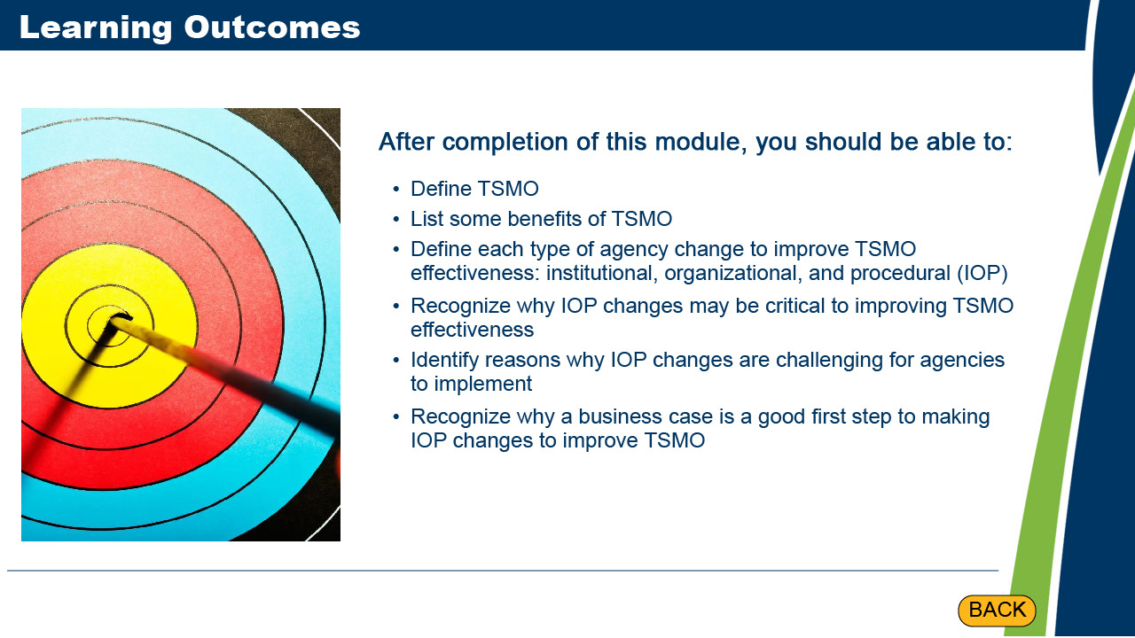
In this module, you have been introduced to foundational information including TSMO benefits, IOP changes to advance TSMO, and why a business case may be necessary to help make those IOP changes. You now should be able to:
Define TSMO
List some benefits of TSMO
Define each type of agency change to improve TSMO effectiveness: institutional, organizational, and procedural (IOP)
Recognize why IOP changes may be critical to improving TSMO effectiveness
Identify reasons why IOP changes are challenging for agencies to implement
Recognize why a business case is a good first step to making IOP changes to improve TSMO

Close this browser window to return to the menu.

